|  |  |  |
| --- | --- | --- |
| **Sr. No.** | **Contents** | **Page No.** |
| **1** | **Annexure I– Micro Project Proposal** | **1-2** |
| 1.Aims/Benefits of the Micro-Project | 1 |
| 2. Course Outcome Addressed | 1 |
| 3.Proposed Methodology | 1 |
| 4. Action Plan | 2 |
| 5. Resources Required | 2 |
| 6. Name of Team Members with Roll No.’s | 2 |
| **2** | **Annexure II – Micro Project Report** | **3-8** |
| 1.Rationale | 3 |
| 2.Aims/Benefits of the Micro-Project | 3 |
| 3.Course Outcome Achieved | 3 |
| 4. Literature Review | 4 |
| 5.Actual Methodology Followed | 5 |
| 5.1 Flow chart | 5 |
| 5.2 Source code | 6-8 |
| 6.Actual  Resources Used | 8 |
| 7.Outputs of Micro-Projects | 9 |
| 8. Skill developed / Learning out of this Micro-Project | 10 |
| 9. Applications of this Micro-Project | 10 |

**Annexure I**

**Micro Project Proposal**

**“{{MICROPROJECT_TITLE}}”**

**1. Aims/Benefits of the Micro-Project:**

1. Understanding the computer graphics and applications like moving car.

2. To find working mechanism of graphics by using computer graphics.

3. To understand the graphics, functions and execution of the ‘C’ program.

**2. Course Outcome Addressed:**

1) CO1 - Manipulate visual and geometric information of images.

2) CO2 – Implement standard algorithms to draw various graphics objects using C program.

3) CO3 – Develop programs for 2-D and 3-D Transformations.

4) CO4 – Use projections to visualize objects on view plane.

5) CO5 – Implement various clipping algorithms.

6) CO6 – Develop programs to create curves using algorithms.

**3. Proposed Methodology:**

Here we are using for loop statement to create moving car.

We have added functions like delay, line and circle to make the body of car

And many more.

By using this function we are able to move car in proper direction with time controlling function that is delay function.

**4.Action Plan**:

|  |  |  |  |  |
| --- | --- | --- | --- | --- |
| **Sr.**  **No.** | **Details of Activity** | **Planned**  **Start date** | **Planned**  **Finish date** | **Name of Responsible Team Members** |
| 1 | Search the topic | 29/08/2022  4:00pm-5:00pm | 05/09/2022  4:00pm-5:00pm |  |
| 2 | Search the information | 12/09/2022  4:00pm-5:00pm | 19/09/2022  4:00pm-5:00pm |  |
| 3 | Algorithm developing | 26/09/2022  4:00pm-5:00pm | 03/10/2022  4:00pm-5:00pm |  |
| 4 | Flowchart developing | 10/10/2022  4:00pm-5:00pm | 15/10/2022  4:00pm-5:00pm | {{STUDENT_NAME}} |
| 5 | Function making | 31/10/2022  4:00pm-5:00pm | 07/11/2022  4:00pm-5:00pm |  |
| 6 | Coding developing | 14/11/2022  4:00pm-5:00pm | 21/11/2022  4:00pm-5:00pm |  |
| 7 | Debugging | 28/11/2022  4:00pm-5:00pm | 05/12/2022  4:00pm-5:00pm |  |
| 8 | Finalizing Project with its report | 12/12/2022  4:00pm-5:00pm | 19/12/2022  4:00pm-5:00pm |  |

**5. Resources Required:**

|  |  |  |  |  |
| --- | --- | --- | --- | --- |
| **Sr.**  **No.** | **Name of resource / material** | **Specification** | **Quantity** | **Remarks** |
| 1 | Computer | WINDOWS 11, 8GB RAM, 160GB HDD | 1 |  |
| 2 | Operating System | WINDOWS 11 | 1 |  |
| 3 | Compiler | Turbo C/GCC/VS code | 1 |  |
| 4 | Browser | Chrome | 1 |  |

**Names of Team Members with Roll No.’s:**

|  |  |  |  |
| --- | --- | --- | --- |
| **Sr.**  **No.** | **Enrollment No.** | **Name of Team Member** | **Roll No.** |
| 1 | {{STUDENT_ENR}} | {{STUDENT_NAME}} | {{STUDENT_ROLLNO}} |

**Mr. {{TEACHER_NAME}}**

**Name and Signature of the Teacher**

**Annexure – II**

**Micro-Project Report**

**“{{MICROPROJECT_TITLE}}”**

1. **Rationale:**

Creating a Simple Program that displays a Moving car from left to right on screen by programming on Turbo C.

**2.Aims/Benefits of the Micro-Project:**

1. Understanding the computer graphics and its applications like moving car.

2. To find working mechanism of graphics by using computer graphics

3. To understand the graphics, functions and execution of the ‘C’ program

**3. Course Outcomes Achieved:**

1) CO1 - Manipulate visual and geometric information of images.

2) CO2 – Implement standard algorithms to draw various graphics objects using C program.

3) CO3 – Develop programs for 2-D and 3-D Transformations.

4) CO4 – Use projections to visualize objects on view plane.

5) CO5 – Implement various clipping algorithms.

6) CO6 – Develop programs to create curves using algorithms.

**4. Literature Review:**

Here we are using for loop statement to create moving car.

We have added functions like delay, line and circle to make the body of car

And many more. By using this function we are able to move car in proper direction with time controlling function that is delay function.

And like this Our car start moving on the screen using for loop.

* Initgraph()-

This Initgraph function in one of most important function from graphics.h library in ‘C’ Language.

* With this function we initialize (start) graphics in our computer system.
* After this function we will write our remaining graphics program.

**Syntax:**



**Important Points about Initgraph function:**

* The expression provided in the path means here “ “ double quotes argument must path to BGI file from Turbo C.

**Valid expressions for initgraph() function:**

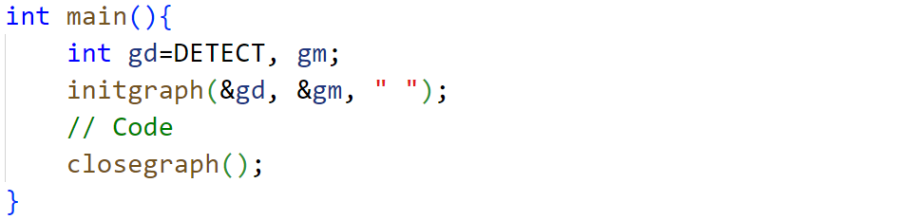

* **Graphics must be get closed with closegraph() function.**
* To design moving car we have to use for loop to iterate.
* To print car body we used line and circle functions.
* To make the land for car we used a line function supported by graphics.h header file.
* We make the draw_moving_car() to embed the all code into it.
* And then this function is get called inside the int main function.
* Lastly we will close the graphics with closegraph() function.

**5 Actual MethodologyFollowed:**

**5.1 Flow Chart:**

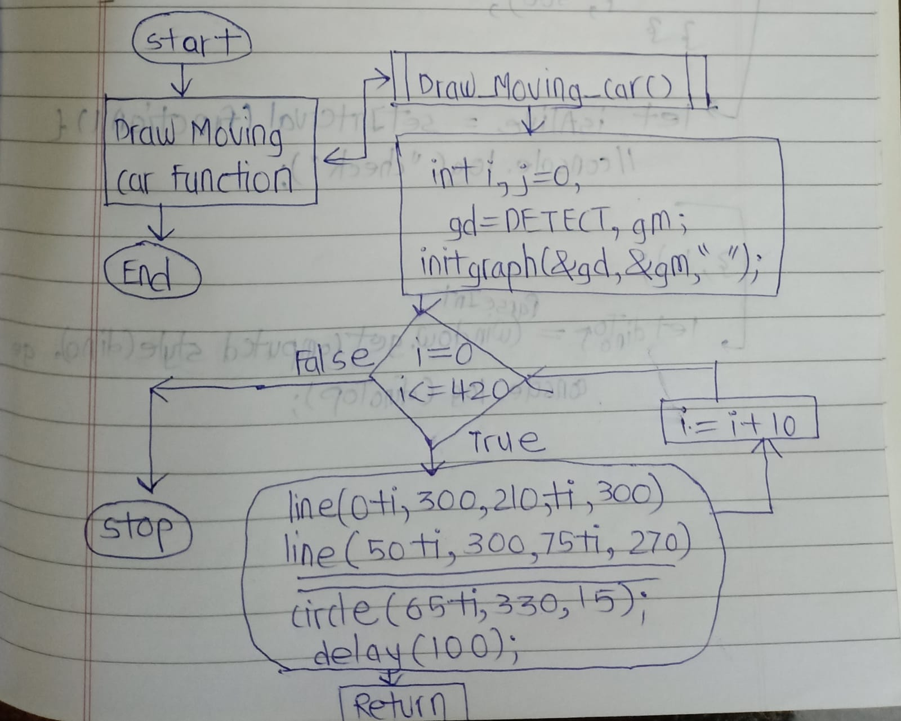

**5.2 Source Code:**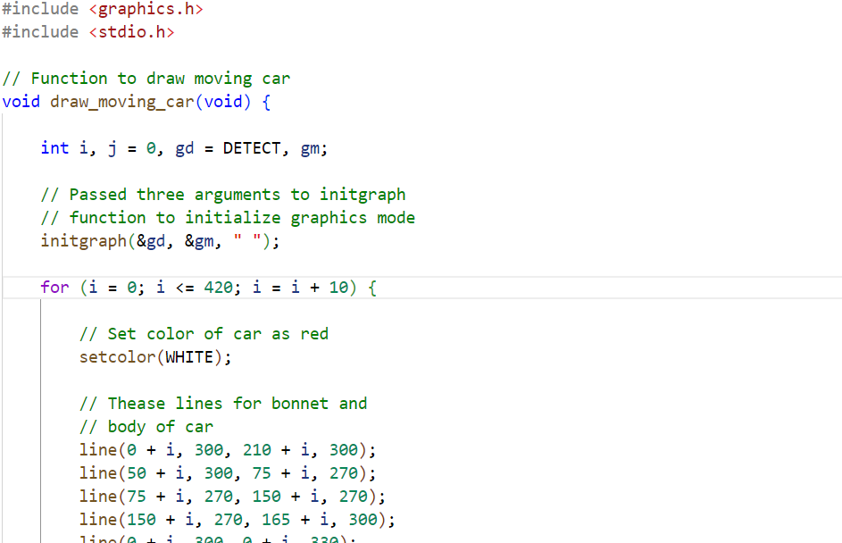

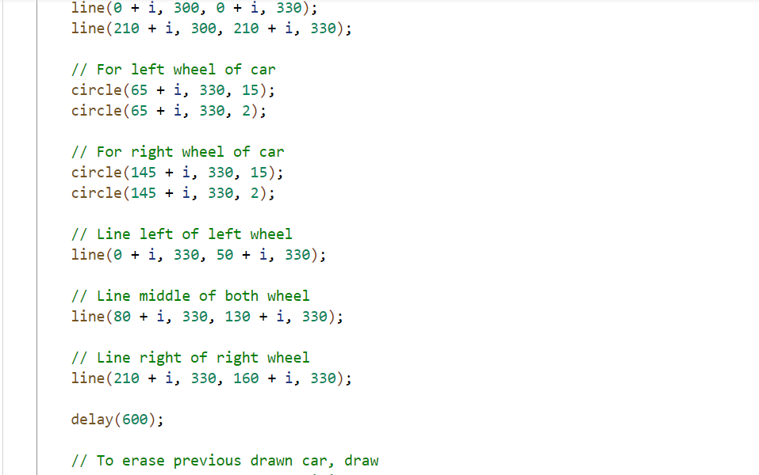

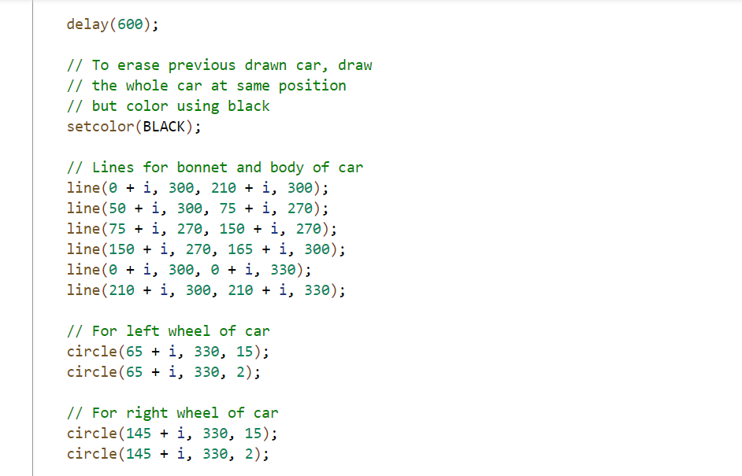

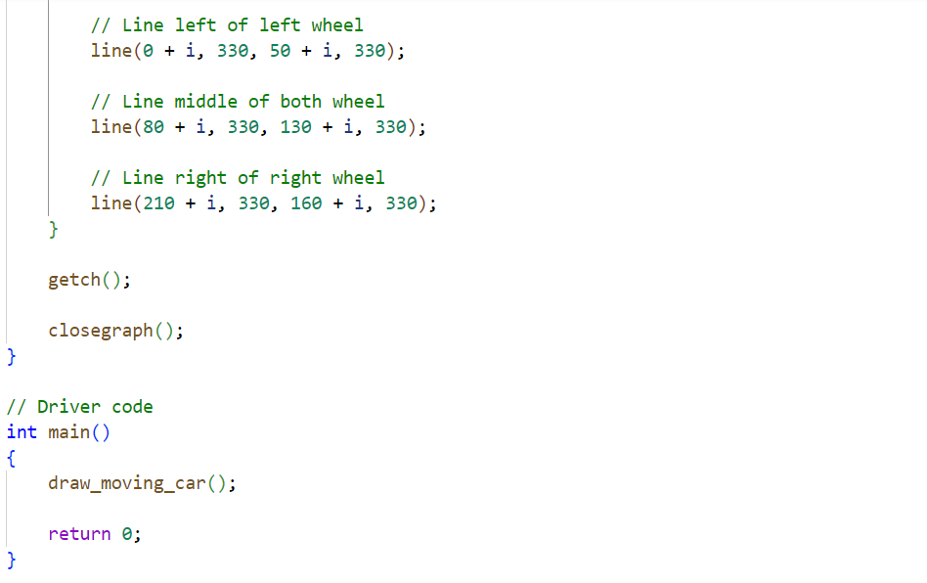

**6. Actual Resources Used:**

|  |  |  |  |  |
| --- | --- | --- | --- | --- |
| **Sr.**  **No.** | **Name of resource / material** | **Specification** | **Quantity** | **Remarks** |
| 1 | Computer | WINDOWS 11,8GB RAM, 160GB HDD | 1 |  |
| 2 | Operating System | WINDOWS 11 | 1 |  |
| 3 | Compiler | Turbo C/GCC/VS code | 1 |  |
| 4 | Browser | Chrome | 1 |  |

**7.Outputs of Micro-Projects:**

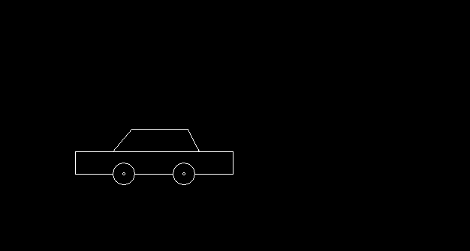







**8.Skill developed / Learning out of this Micro-Project:**

There are so many thing that we learn from this project of

1. We learn that how to make the project in c programming.

2. How to design computer graphics in ‘C’ Language.

3. How to collect the information and how to make the presentation that we learn from this project.

4. We develop our logic implementation for programing and coding as well as for designing graphics.

5. We learn much more functions of graphics.

6. We learn how to create different designs and shapes with different graphical function.

7. We learn some keywords and functions from ‘graphics.h’ and ‘stdio.h’ header file.

8. We learnt lot more things like logic building and enhancement from this project.

**9. Applications of this Micro-Project:**

1. 1. also be used to design graphics with implimenting this project on large scale.It can be used to understand computer graphics.
2. And we also learn how to animate our car by using for loop.
3. It can also be used to make animations UI development , Game development Etc…..

*********